Experiment No. 2
Frequency Shift Keying (FSK) Modulation and Demodulation

Object:
- To study and understand the principle of Frequency Shift Keying modulation and demodulation
- To learn how to implement FSK modulation and demodulation using Matlab-Simulink.
- To evaluate the performance of FSK modulation and demodulation over AWAG channel.
Theory:
The FSK mode was introduced in the year 1900 to use in the mechanical teleprinters. The standard speed of these machines was 45 baud, equivalent to about 45 bits per second. Today, a standard telephone modem operates at the thousands of bits per a second. Cable and wireless modems work at more than the 1,000,000 bps (one megabit per second or 1 Mbps), and the optical fiber modems function at lots of Mbps. But the fundamental principle of FSK modulation has not changed in more than half a century.
Frequency-shift keying (FSK) is the frequency modulation system in which digital information is transmitted through the discrete frequency change of a carrier wave. The technology is used in communication systems such as amateur radio, caller ID, and urgent situation broadcasts. In digital communication, the modulating wave consists of binary (2-level) or an M-array (M-level) encoded version of data. The simplest FSK is binary FSK (BFSK). Binary FSK is a modulation scheme typically used to send digital information between digital equipment such as teleprinters and computers. The data are transmitted by shifting the frequency of a continuous carrier in a binary manner to one of the two discrete frequencies. One frequency level is called as ‘Mark’ and the other is called as ‘Space’. The mark and space represent binary one and zero respectively.
A binary FSK signal can be generated either by selecting between the outputs of two different oscillators or by switching the frequency of a single oscillator. When the two-oscillator approach is used, the relative phasing of the two outputs can be uncontrolled, or the oscillators can be phase-locked to a common reference so that the relative phasing of their outputs is fixed and known.

FSK Modulation
An M-array FSK modulated signal can be expressed as:
$$X_{FSK}\left(t\right)=\left\{\begin{matrix}A_{i}\cos\left(ω_{c1}t+θ_{0}\right) \\ A_{i}\cos\left(ω_{c2}t+θ_{0}\right)\end{matrix}\right. i=1,2……M$$
Where the amplitude A_{i} has M possible values (M levels), ω_{c1,} ω_{c2} is the angular frequencies and θ₀ the phase as a constant.
If the system uses a binary FSK modulation 2-FSK modulation, M=2 (A₁=$A_{1}\cos\left(ω_{c1}t+θ_{0}\right)$ and A₂=$A_{2}\cos\left(ω_{c2}t+θ_{0}\right)$), where A₁, A₂ are an arbitrary constants. The BFSK can be visualized as sum of two ASK modulated waves. The bandwidth of BFSK is
(1)
$f_{c1}-f_{c2}≫2f_{b}$ (2)
FSK is divided into noncoherent and coherent forms. In noncoherent forms of FSK, the instantaneous frequency shifts between two discrete values termed the "mark" and "space" frequencies. In coherent forms of FSK, there is no phase discontinuity in the output signal.
Figure 1 shows Binary FSK modulation waveforms. There are sharp discontinuities shown at the transition points. These result in the signal having an unnecessarily wide bandwidth. Band limiting is generally introduced before transmission, in which case these discontinuities would be ‘rounded off’. The band limiting may be applied to the digital message, or the modulated signal itself. Figure 2 shows the structure of binary FSK modulator.
As FSK is the combination of two ASKs as shown in Fig.2, the PSD of BFSK would also be summation of two Sinc functions. But the separation of the central lobe of the Sinc functions would greatly depend on the difference of frequencies fH and fL is comparison to the bit frequency f_{B} = 1/T_{B}. Different cases of this comparability are shown in Fig.3.

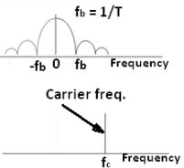
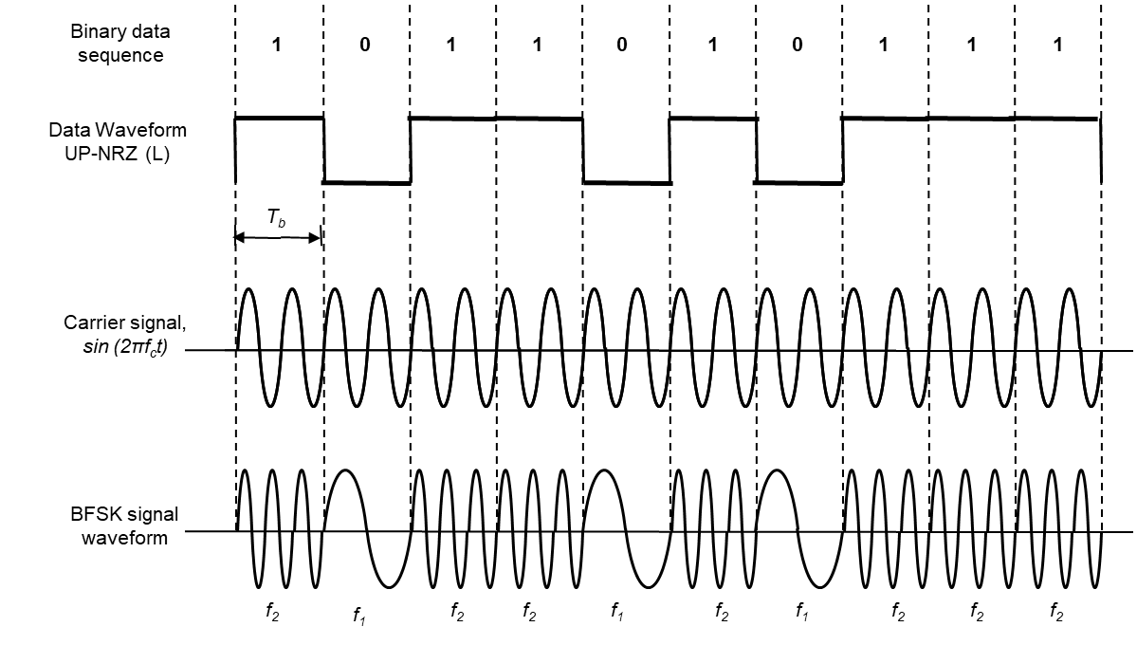

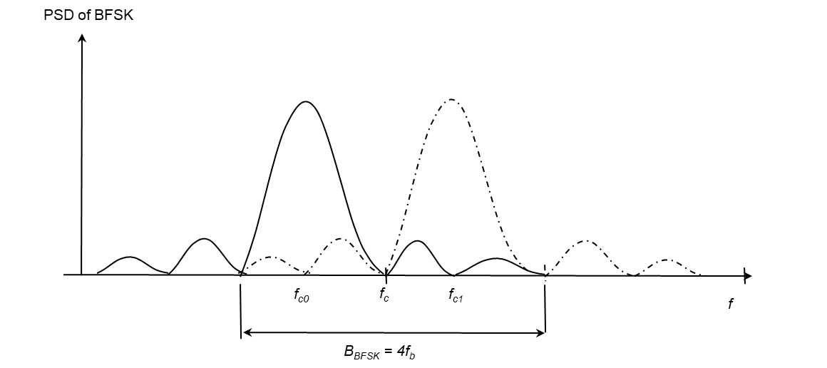

Figure 1 FSK modulation waveforms and their frequency domains

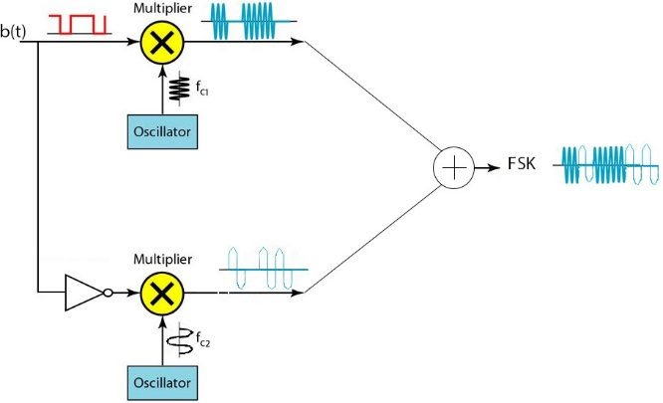

Figure 2 Structure of FSK modulator

Fig.3 PSD of BFSK: (a) f_{H} − f_{L} < 2/T_{B}, (b) f_{H} − f_{L} = 2/T_{B}, (c) f_{H} − f_{L} > 2/T_{B},
(d) f_{H} − f_{L} >> 2/T_{B}

FSK Demodulation
The method of demodulation is an important factor in determining the selection of a modulation scheme. There are two types of demodulation which are distinguished by the need to provide knowledge of the phase of the carrier as follows:

- Coherent (Synchronous) FSK Demodulation
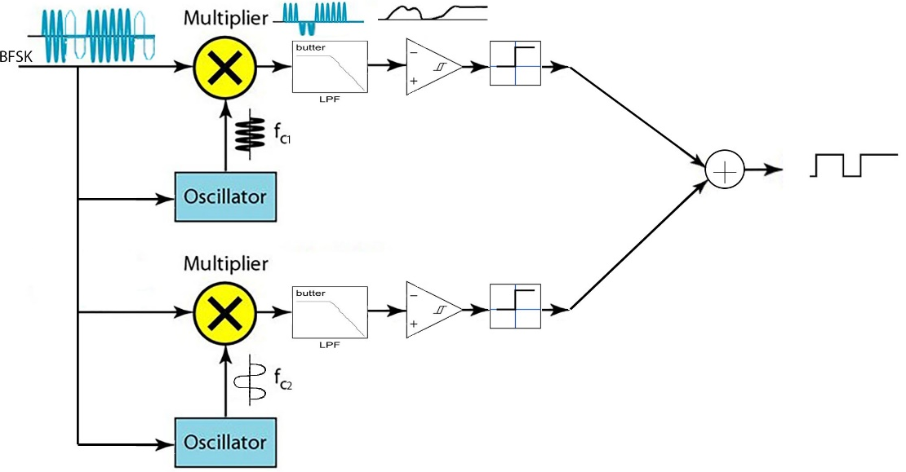
As the binary FSK signal is generated using two carrier frequencies, the coherent detector consists of two correlators that are individually turned to two different carrier frequencies to represent symbol 1 and 0. A correlator is the combination of a multiplier followed by an integrator (LPF). The same BFSK signal is multiplied by two different carrier signals and the passed separately through the LPF. The outputs of the LPF must be inverted type, i.e., if one is upper going, the other must be lower going. Next, the outputs are fed to the decision deice which is essentially a comparator. If the output produced in the upper path is more than the output produced in the lower path, the magnitude comparator will decide in favor of symbol 1. Similarly, if the output of the upper path is less than that of the lower path, the comparator will decide in favor of symbol 0. This type of digital communication receivers is also called as correlator receiver carrier.
Figure 4 Structure of Coherent FSK demodulation

Coherent reception is facilitated by the fact that once recovered subcarriers are phase-locked to the FSK signal at the receiver, phase-lock can be easily maintained because the relative phasing of the received bursts does not change from bit to bit. In fact, it is not really necessary that an integer number of cycles of f₁ and f₀ fit within a bit interval. Phase continuity can be maintained from bit to bit so long as an integer number of cycles of the difference frequency f₁ − f₀ fit exactly within a bit interval. (This is also a sufficient condition for orthogonality.)
The operation of keeping the phase of the replica carrier is difficult to be achieved. In general, Oscillators are sensitive to temperature, noise, and will gradually drift in frequency and phase. Figure 4 shows a block diagram of coherent FSK demodulator and each stage’s output waveforms.
- Non-coherent (Asynchronous) FSK Demodulation
In contrast, noncoherent FSK demodulation scheme does not need to knowledge of the carrier phase and is sensitive only to the power of the signal, with ASK, the power is either present or not. This demodulation scheme requires simple and cheap circuitry, but has poorer performance and effective against the noise effect.
As in case of ASK, binary FSK also can be demodulated non-coherently using envelope detector. The received BFSK signal is applied to the bank of two band pass filters (parallel BPF combination) with central pass frequencies f_{H} and f_{L}. Each filter is followed by an envelope detector. The envelope of the FSK signal is detected via diode. In both cases the diode is followed by a low pass filter, which removes the residual carrier components. It is not at all difficult to understand that, the output of the envelope detectors would be P_{H} and P_{L}, i.e., the outputs would be inverted to each other. Therefore, the comparator as shown in Fig.5 would decide in favor of symbol 1 is PH >PL, and decision would be made in favor of symbol 0, otherwise.
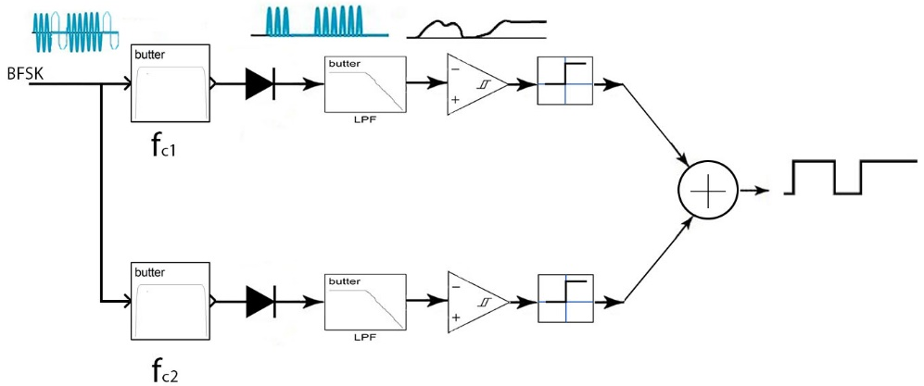
Figure 5 Structure of Non-coherent FSK demodulation
Procedure
Part A: Simple FSK Modulator and Coherent Demodulator
- Implement the FSK modulator and demodulator shown in Figure 6.
- Set the parameters of all sinewaves by the amplitude 1 V and frequencies f_{c1} and f_{c2}= 15*2*π and 5*2*π rad/sec respectively.
- Set the parameters of the Analog Filter Design as follows:
Design method: Butterworth, Filter type: Lowpass, Filter order: 8, Passband edge frequency(rad/sec): 30
- Plot the signals in each scope.
- From equation 2 and Figure 3, if the difference between f_{c1}-f_{c2}<10, what happened?
Figure 6 Simple FSK Modulator and Coherent Demodulator

Part B: Realistic BFSK modulator and Coherent demodulator
1. Implement the Realistic Coherent FSK modulator and demodulator shown in Figure 7.
- Repeat the setting of the parameters of the components as shown in Part A.
- Set the parameters of Analog Filter Design (Mod) as follows:
Design method: Butterworth, Filter type: Bandpass, Filter order: 10, Lower Passband edge frequency(rad/sec): 0.16, Higher Passband edge frequency (rad/sec): 350
Notice: 1 Radian per second is comparative to 1/2π Hertz
- Set the parameters of AWAG channel as follows:
Input processing: Columns as channels, Initial seed: 67 (or any number)
Mode: Signal to noise ratio (SNR), SNR (dB):70, Input signal power (watts):1
- Plot the signals in each scope.
- What happened when you changed SNR (dB) of the channel to 10?

Part C: Realistic BFSK Modulator and noncoherent Demodulator
- Implement the Realistic BFSK modulator and noncoherent demodulator shown in Figure 7.
- The diode is represented by Positive linear transfer function (Poslin).
- Set parameters of Analog Filter Design (DeMod 1) as follows:
Design method: Butterworth, Filter type: Bandpass, Filter order: 10, Lower Passband edge frequency(rad/sec): 10*2*pi, Higher Passband edge frequency (rad/sec): 20*2*pi.

- Set parameters of Analog Filter Design (DeMod 2) as follows:
Design method: Butterworth, Filter type: Bandpass, Filter order: 10, Lower Passband edge frequency(rad/sec): 0.16, Higher Passband edge frequency (rad/sec):8*2*pi.
- Set the parameters of the Analog Filter Design (Demod) fc1 as follows:
Design method: Butterworth, Filter type: Lowpass, Filter order: 8, Passband edge frequency(rad/sec): 30
- Set the parameters of the Analog Filter Design (Demod) fc2 as follows:
Design method: Butterworth, Filter type: Lowpass, Filter order: 8, Passband edge frequency(rad/sec): 20
- Repeat the setting of the parameters of the components as shown in Part B.
- Plot the signals in each scope.
- What happened when you changed SNR (dB) of the channel to 10?

Figure 7 Realistic FSK Modulator and Noncoherent Demodulator

Discussion
- From the result, compare between coherent and incoherent demodulation of FSK signal when the signal to noise ratio (SNR) of AWAG channel is high or low.
- A binary FSK signal can be generated either by selecting between the outputs of two different oscillators or by switching the frequency of a single oscillator. What is the importance of using a single oscillator?
- As mentioned above, FSK is the combination of two ASKs as shown in Fig.2, explain through equations what happen if there is a phase error θ_{c} between the transmitted FSK signal and local (replica) carrier signals in coherent FSK demodulator. Then what happen if θ_{c}=90º.
- Describe the importance of using Bandpass filters in BFSK noncoherent demodulator.
- Explain the importance of the condition $f_{c1}-f_{c2}≫2f_{b}$ with figures.
- Compare the bandwidth of BASK and BFSK?
- Specify the applications of BFSK?

